Topic 4: Talking about your Education
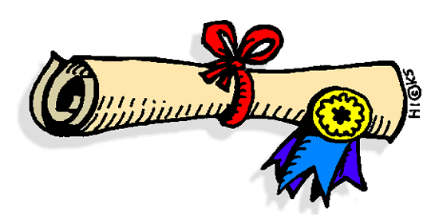
- Discuss
  - What is the difference between education and training?
  - How did you choose your field of study/ your major?
  - What kinds of extra activities do you do at university? Which ones might employers want to know about?
  - Why are your grades so good, so bad, or just okay?
  - What do you think a company wants to know about when they say, "Tell me about your educational experience"?

- Read the article and answer the questions

Formal Education
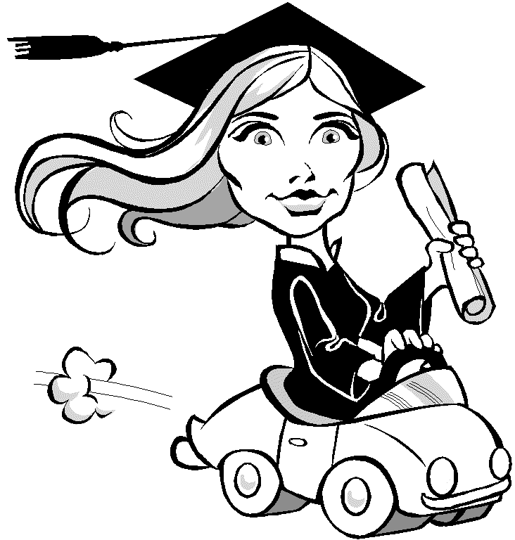
"Tell me about your educational experience." is a basic interview request you might hear. Generally, the best approach is to talk about your educational experience positively and connect your degree and educational experiences to the job. Besides the name of your university and your degree, also mention any special successes like if you graduated with honors, completed your course of study in a short amount of time, or were part of important academic organizations. Also mention work-study opportunities, internships, job shadowing or on-the-job training you participated in. Describe how the information and skills you gained will help you be the best person for the job.

Specialized Professional Training
Also, mention any specialized professional training you've done. For example, if you or your last company sent you to a vocational institute to participate in an intensive program designed to make you proficient on every type of accounting software on the market, it's definitely worth mentioning.

For example:
"As you have seen on my resume, I will graduate with a Management degree from SCH University in March. My college experience was great in terms of both character development and learning about the different aspects of business and finance. I was passionate about the classes I took and was also involved in the university’s finance club. The Internship I did last summer was a great learning experience. I was exposed to the day-to-day activities in a financial management firm and also got to work on some real financial analysis. All of my experiences prepared me well for success in financial management. One important skill I learned was time management. How we manage our time will determine our success or failure. A second skill was… “
(adapted from forbes.com)

- When talking about formal education and professional training, what should you connect it to?
______________________________________________________________________________
- When talking about your formal education, what aspects should you talk about?
______________________________________________________________________________
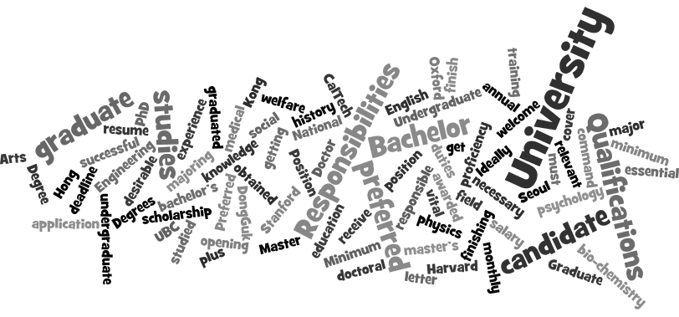

- Discussion:
- Do you see any words you don’t know in the word art? What do you think they mean?
- What are you majoring in? Was it your first choice?
- When will you graduate? How do you feel about that?
- What school did you really want to go to?
- Do you want to do a master’s degree or a PhD? Why?
- In a job interview, how can you respond to: “Tell me about your educational background.”
- What other interview questions might ask about your education?
- What is the difference between education and training?

- Common Western Educational Qualifications:

- Undergraduate Degrees/Studies
2 year degrees after high school = an associate degree
4 year degrees after high school = a bachelor’s degree (BA, BEd, BSc, BS, BComm,…)

- Graduate Degrees/Studies
1-2 year masters degrees after bachelors= A master’s degree (MA, MSc, MEd, MBA,…)
3-4+ year doctorate degree after bachelor’s and master’s degree: a doctorate degree
(PhD, EdD, …)

Note: formal VS common names of degrees:
a “Bachelor of Arts degree” VS a bachelor’s degree in arts
a “Master of Education degree” VS a master’s degree in education

Future: I will finish/receive/get/have a Bachelor/Master/Doctor of Arts Degree (in history).
Present: I am doing/getting/finishing a degree in math.
Present Perfect: I have been doing/working on a doctoral degree in engineering since 2006.
Past: I finished/received/got/did/have a bachelor’s/master’s/doctoral degree in science.
- Common Interview Questions about Education

- Tell me about your educational background.
- Why did you choose your college major?
- What skills did you develop at University?

- Expressions:
- to study (major) at (school)
- to graduate from (school) with a (degree) / to graduate with a (degree) from (school)
- to obtain/get/receive a (degree) from (school)
- to complete/finish a (degree) at (school)
- to major in (field)
- to be a (field) major
- to be awarded a scholarship to study (major) at (school)

- Circle the correct words:
- I’ll (finish / graduate) from Yonsei University with a Bachelor (of / in) Engineering degree.
- Jennifer (obtained/awarded) a psychology degree from (Harvard/math) last year.
- I (completed / studied) a master’s degree in (Chinese / PhD) at Hong Kong University.
- I was (majoring/finishing) in bio-chemical engineering at (bachelor’s degree / Cambridge University)
- I (studied / completed) physics (at / in) Seoul National University.
- I have been (doing / graduating) an English literature (degree/ Bachelor of) for 3 years.

- Practice: With a partner, practice the following sentences. Change the underlined parts:
- I studied physics at Seoul National University.
- I have been studying management at Seoul National University since 2011.
- I will graduate from Soonchunhyang University with a Bachelor of Engineering degree.
- He graduated with a PhD in bio-chemistry from DongGuk University in June.
- I obtained a medical degree from Harvard last year.
- I completed a master’s degree in education at Hong Kong University.
- I was majoring in social welfare.
- I’m an English major, but I want to be a physics major.
- I was awarded a scholarship to study psychology at UBC.

- Write three different sentences to describe your university education/ educational qualifications:
- ______________________________________________________________________________
- ______________________________________________________________________________
- ______________________________________________________________________________
Practice: Ask two people about their education. Answer their questions about yours.

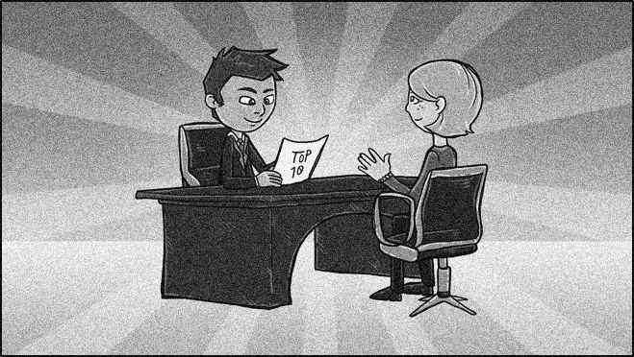

- Interview Activity
With a partner, think of a company and a job you would both like. Then interview each other for the position.

Pretend it’s a real interview.
- Introduce yourselves to each other
- Make small talk
- Interviewer: Ask 4 or 5 of the questions below
- Job Seeker: Ask some questions about the position or company
- Finish the interview

- Why should we hire you?
- What qualifies you for this job?
- What are your greatest strengths/weaknesses?
- Which adjectives would you use to describe yourself?
- What type of work environment do you like best?
- Why did you leave your last job?
- Tell me about your educational background.
- Why did you choose your college major?
- What skills did you develop at University?

(Topic images from: graduating girl , diploma, cap throwers)

