- What do you think the following idioms to describe people mean?
- Jonathan is a real go-getter. He is always looking for opportunities.
- I haven’t done any programming before, but I’m a quick study.
- You can’t keep being so competitive with your coworkers. Try to be more of a team player.
- The presentation will be ready and it will be great. I always deliver the goods.
- Don’t wait for them to give you a raise. Take the bull by the horns and ask for it.

- A Personal Inventory- Preparing to Sell Yourself

Every person who is looking for a job is like a salesperson. They are trying to sell is themselves to their potential employers. Good salespeople always know their customer and their products, so before going to the interview, you have to learn about the company, the industry, the position and about yourself.

Potential employers have many specific questions about you (the product). They want good quality information about you before hiring a new employee. It is important to be prepared so you can give them good and true answers.

Employers want to know about the following:
- your job skills
- the successes you have had in previous jobs
- every type of job experience you have ever had
- your education or training experiences
- if you respond well to supervision
- why you left your last job
- why they should hire you

In order to prepare for getting the job that is just right for you, a personal inventory is useful. It will help you prepare for these questions. It is essential that you are prepared with answers for them. Many people do not take the time to sit down and think about all of their skills, talents, and the accomplishments experiences and education that are important to an employer.

A personal inventory is a list that describes you in great detail. Your personal inventory will be unique because you are a unique person. It will help you answer these questions because you will have identified your characteristics, accomplishments, motivation for working, skills, and interests.

Today we will look at characteristics and skills.

Questions:
- What are you trying to do when you try to get a job?
- What things should you have studied about before going to an interview?
- What is a personal inventory?

- What Are Your Strengths (and Weaknesses)?

1. Personal Characteristics (Adjectives)
Assess the strengths. Do you feel that you are:

- Ambitious? Are you career oriented with a strong desire to attain personal and financial success?
- Articulate? Are you able to communicate ideas and opinions clearly and forcefully?
- Cheerful? Are you pleasant? Able to smile easily?
- Confident? Do you have a high level of self-esteem? Are you self-assured?
- Conscientious? Do you have good work habits? Are you punctual?
- Cooperative? Are you helpful? A good team worker?
- Creative? Can you come up with new ideas or think of solutions to problems?
- Decisive? Can you analyze situations and make clear decisions.
- Dependable? Are you steady? Do you keep promises? Do you have good work habits?
- Efficient? Do you make good use of time? Perform high quality work?
- Energetic? Do you have a high level of mental and physical endurance? Work quickly?
- Hardworking? Do you believe in working hard? Are you eager to take on difficult tasks?
- Loyal? Are you supportive of the best interests of your employer and colleagues?
- Organized? Are you orderly? An efficient planner?

Interview Questions:
What is your greatest strength? What adjective would you use to describe yourself? How would you describe yourself? (Why should we hire you?) One Common way to answer:

- Describe your characteristic
- I’m a very efficient person. (a/an………person, a/an………employee)

- I’m quite organized.
- I can be very articulate.
- I’m extremely ambitious.
- I’m very conscientious.

- Give a general example

- I always…
- I usually…
- I often…
- I never…

- Give a specific example (small story) about you that shows the characteristic
(Often you will be asked for a specific example by the interviewer if you don’t give one)

- When I was at university,…
- At my last job,…
- While I was the office manager at Acme Inc, ….
- Last year,….

Example: I’m a very dependable person. I always do what I say I will. At one point during my last job, I was in charge of four projects at one time. Despite the heavy workload, I made sure all four were completed successfully and on time.

Practice: With a partner, ask and answer, “How would you describe yourself?” (or a similar question)
- Try at least two different answers
2. “Transferable Skills” (HR buzzword): Skills from different experiences that can be applied to future jobs. They are skills needed to perform well for almost any job and life in general.

Some Common Skills Categories:

- Leadership Skills
- Organizational Skills
- Teamworking Skills
- Analytical Skills
- Creativity (Creative Skills)
- Communication Skills
- Interpersonal Skills
- Negotiation Skills
- Research Skills
- Planning Skills

a) Skills categories and some examples:

Communication Skills
  - give presentations
  - explain something (ideas/how something works)

Interpersonal Skills
  - get along with ‘difficult’ people
  - listen to others’ points of view

Leadership Skills
  - delegate tasks
  - motivate people

Organizational Skills
  - decide on priorities
  - meet deadlines

Creativity
  - invent something
  - solve problems

Research Skills
- think critically
- find and analyze information

Interview Questions:
What is your greatest strength? How would you describe yourself? (Why should we hire you?)
One Common way to answer (very similar to the answers for characteristics):

- Describe your characteristic

- I have excellent creativity.
- I have very good research skills.
- I have well-developed communication skills
- My leadership skills are well developed.
- My organizational skills are strong.
- My interpersonal skills are excellent.

- Give a general example

- I can explain things clearly.
- I am able to listen to others’ points of view.
- I’m good/excellent at writing reports.
- I always meet deadlines.

- Give a specific example (small story) about you that shows the characteristic
(Often you will be asked for a specific example by the interviewer if you don’t give one)

- When I was at university,…
- At my last job,…
- While I was the office manager…
- Last year,….

Example: I have excellent research skills. I’m very good at finding and analyzing information. At university, I wrote many research papers. I always received the highest grades and my professors always told me they were excellent.

Practice: With a partner, ask and answer, “What is your greatest strength?” at least once.

b) Activity: Find a different person for each box:
- A- Can you analyze data? –> B- No, I can’t. / Yes, I can. I have really good research skills.
- A- Are you able to motivate people? –> B- No, I’m not. / Yes, I am. I have strong leadership skills.
- A- Are you good at giving presentations? –> B- No, I’m not. / Yes, I am. I have good communication skills.

can analyze data | is able to solve problems | is excellent at writing reports | is good at suggesting alternatives
Is able to conduct surveys | is able to explain things to others | is great at giving presentations | can resolve disputes
is able to work with ‘difficult people’ | Is excellent at motivating people | can delegate tasks effectively | is good at meeting deadlines
is able to contribute in meetings | is good at changing peoples’ minds | can negotiate with people | is able to convince people to do things

c) Write 6 things about yourself:
Characteristics:
- I’m very __________________________________________________________________.
I ________________________________________________________________________.
- I’m extremely______________________________________________________________.
I ________________________________________________________________________.
- I can be very _______________________________________________________________.
I _________________________________________________________________________.
Skills:
- I have very good _____________________________________________________________.
I __________________________________________________________________________.
- I have well developed__________________________________________________________.
I __________________________________________________________________________.
- My ___________________________________________________________ is/are excellent.
I __________________________________________________________________________.

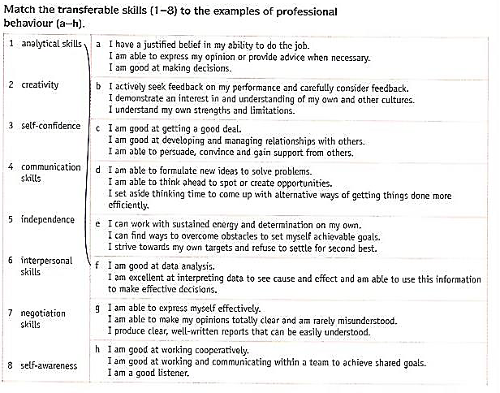

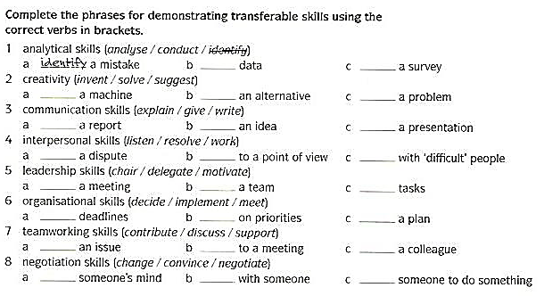
From: Cambridge English for Job-hunting

1.f, 2.d, 3.a, 4.g, 5.e, 6.h, 7.c, 8.b
1.idendify/analyze/conduct, 2.invent/suggest/solve, 3.write/explain/give, 4.resolve, listen, work, 5. chair/motivate/ delegate, 6.meet/decide/implement, 7.discuss/contribute/support 8.change/negate/convince
Extra- (Transferable Skills List: Princeton Career Services- Transferable Skills)

Interpersonal Skills

- Relating well with others
- Assisting others
- Responding to concerns
- Resolving conflicts
- Motivating people
- Being a team player

Organization Skills

- Follow-through
- Meeting deadlines
- Multi-tasking
- Planning
- Setting and attaining goals
- Time management

Leadership Skills

- Decision-making
- Delegating
- Evaluating
- Initiating
- Managing
- Motivating others
- Planning
- Problem-solving
- Supervising
- Team-building

Communication Skills

- Advising
- Articulating
- Explaining
- Instructing
- Persuading or selling
- Presenting
- Public speaking
- Training
- Translating
- Writing & editing

Extra- Common Interview Questions

- Why should we hire you?
- Why do you want to work for us?
- What interests you about this job?
- What type of work environment do you like best?
- What qualifies you for this position?
- What is your greatest strength and your biggest weakness?
- What do people often criticize you about?
- Which adjectives would you use to describe yourself?
- What makes you want to work hard?
- What motivates you?
- Tell me about your educational background.
- Why did you choose your college major?
- What skills did you develop at University?
- Where do you see yourself 5 years from now?
- What do you do like to do in your spare time?
- What are some of your hobbies and interests?
(Competency Based Questions)
- Tell me about a time when you showed strong leadership skills.
- Tell me about a time when you had to make a difficult decision.
- Tell me about a time you had a conflict with a coworker and how you resolved it.

