1. **Countries**- Write the letter under the word corresponding to the picture(s) for that country.

|  |  |  |  |  |
| --- | --- | --- | --- | --- |
|  |  |  |  |  |
| a | b | c | d | e |
|  |  |  |  |  |
| f | g | h | i | j |
|  |  |  |  |  |
| Ireland | Japan | England | Brazil | Mexico |
|  |  |  |  |  |
| The US | Canada | Australia | Korea | Germany |
|  |  |  |  |  |

Examples: I’m from **Ireland**. My friends are from **Mexico**.

s.b. + is/am/are + from ___________.

1. **Jobs**

Rearrange the letters to the correct name of each job.

|  |  |  |
| --- | --- | --- |
| http://crizaze.com/wp-content/uploads/2013/12/Photographer.jpg | http://cdn.playbuzz.com/cdn/a722e310-56c9-46de-9672-154d07349a81/a92684e2-6ad5-4f90-8a35-4c2c7f02f7ca.jpg | http://regenorthoclinic.com/wp-content/uploads/2014/09/doctor-1.jpg |
| 1. oapgohpertrh | 1. atehrec | 1. oocrtd |
|  |  |  |

|  |  |  |
| --- | --- | --- |
| http://blogs.20minutos.es/chicade30/files/depp-mercurybiopic.jpg | http://i.dailymail.co.uk/i/pix/2012/01/26/article-0-1177A45E000005DC-437_634x405.jpg | http://www.schoolsoup.com/images/african-american-student.jpg |
| 1. toacr | 1. satitr | 1. ntusetd |
|  |  |  |

Examples: They’re **cooks**. My mother is a **nurse**.

s.b. + is/am/are + a/an ___________.

1. **Family and Relationships**

Write the words in the correct boxes

brother classmates father friend

mother parents sister wife

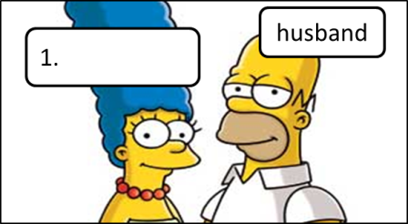 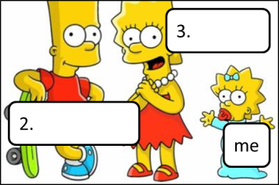

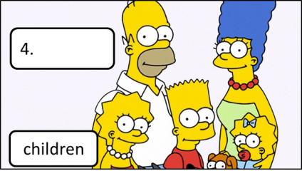 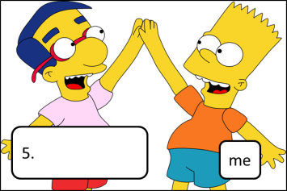

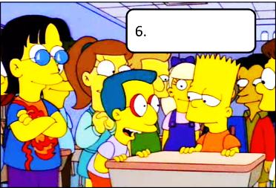 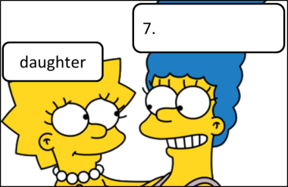 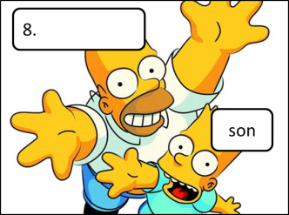

Examples: She’s his **classmate**. They’re our **parents**.

s.b. + is/am/are + my/your/his/her/their/our _____________.